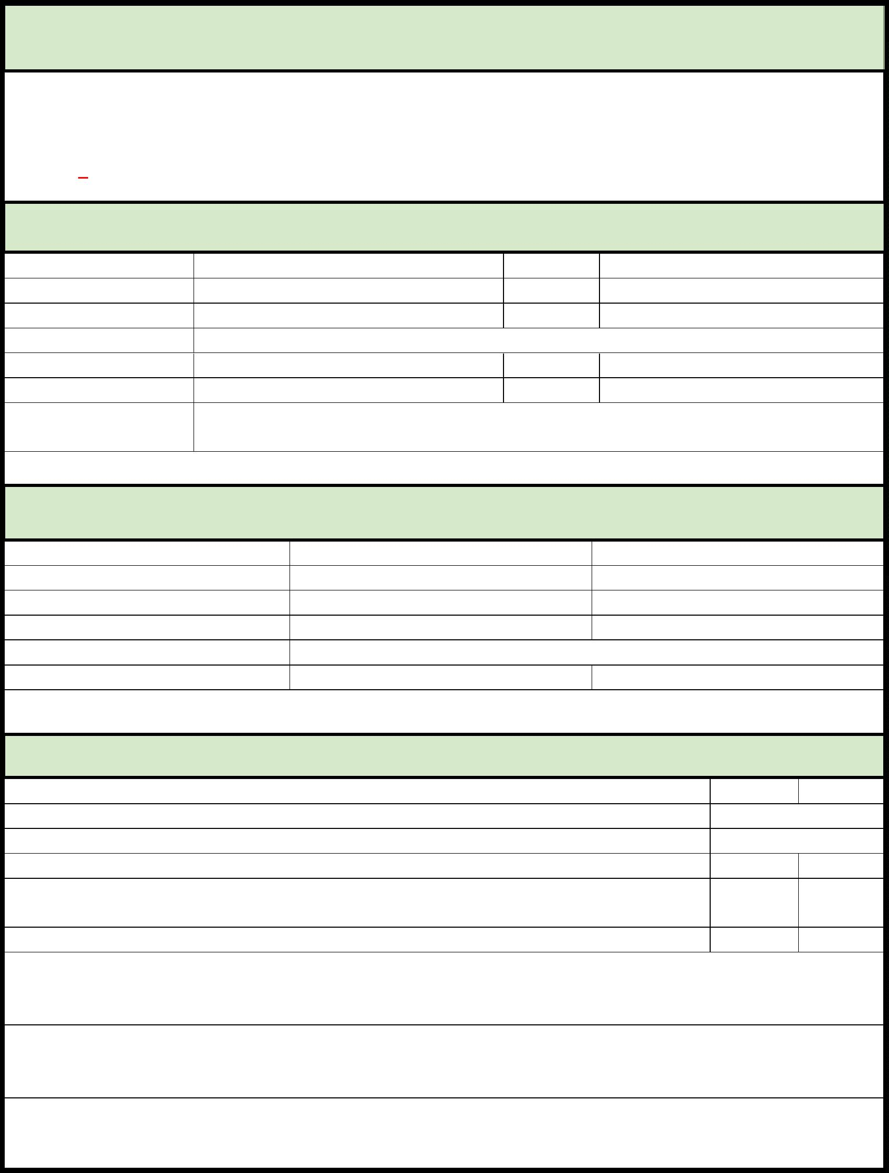
EMERGENCY FOOD AND SHELTER PROGRAM – PHASE 42 APPLICATION
PLEASE TYPE OR PRINT ALL INFORMATION
FEMA has awarded St. Landry Parish a total of $28,286 the Phase 42 of the Emergency Food and
Shelter Program. Organizations interested in applying for any of this funding, must complete this
application and return it to the St. Landry-Evangeline United Way at 5367 I-49 S. Service Rd, Opelousas,
La by June 12, 2026.
ORGANIZATION INFORMATION
ORGANIZATION: UEID #:
PHYSICAL ADDRESS: PHONE #:
MAILING ADDRESS: FAX #:
FEDERAL TAX I.D. #:
CONTACT PERSON: TITLE: CONTACT’S CELL: EMAIL:
SIGNATURE:
REQUEST FOR FUNDS
MASS SHELTER $ .00 # OF NIGHTS:
FOOD/MEALS $ .00 # OF PEOPLE FED:
RENT/MORTGAGE ASSISTANCE $ .00 # OF BILLS:
UTILITY ASSISTANCE $ .00 # OF BILLS:
ADMINISTRATION N/A
TOTAL $ .00 N/A
FUNDING INFORMATION
Did this organization receive EFSP funding in Phase 41? Yes No
If yes, how much? $
If yes, how many clients were served? # Served:
During the last calendar year, were clients denied service due to inadequate funding? Yes No
Is there specific criteria for client eligibility to receive benefits from your program? Yes No
If yes, attach a copy to this application.
Was funding from other sources used for this program last year? Yes No
If yes, please list your top two other funding sources:
#1: #2:
Please list the Top 2 ways which Phase 42 funds will be utilized.
#1: #2:
Attach a copy of your most recent Financial Statement to the back of this application.
Attach a copy of your current Board of Directors roster to the back of this application.

